CSDA 1010

Lab 1

Direct telemarketing campaign of a Portuguese banking institution

BDA Group

Adeel Javed
Alan Yung
Lucas DiMonte
Mariam Daoud
Nadir Khan
Vivek Chaubey

June 26, 2018

Business Problem Framing

The banking industry’s background
Our client is a Portuguese retail bank that provides various financial services and investment products. Following the financial crisis in 2008, the bank has been under growing pressure to increase profits and reduce costs. Moreover, new government financial regulations mandated that Portuguese banks increased their capital deposits. Consequently, the bank decided to raise its required capital by selling long-term deposits to its existing customers.

Figure 1: raising capital in Portugal following the global financial crisis of 2008

The bank’s marketing strategy
The bank decided that the quickest way to sell long-term deposits to its existing customers is by leveraging its existing contact-centre to deploy a telemarketing campaign. The campaign is based on direct outbound and inbound telephone calls. The bank’s telemarketers would telephone each customer that appears on a list of identified prospective customers and sell them long-term deposits, or sell them the service when they telephone the contact-centre for any reason. However, the bank needs to optimize its telemarketing campaign by ensuring that its marketing and sales budget is effectively used. They need to identify and talk to those customers who are most ready to buy their long-term deposit services, that is, to maximize their marketing and sales success. Nevertheless, because, some prospective customers will still refuse to buy the service after having been contacted several times, the bank wants those failed customers to be a very small percentage in the list of the targeted customers.
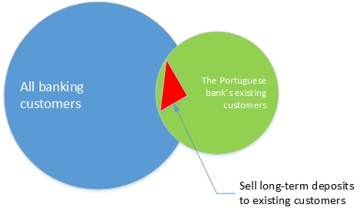
Figure 2: the bank’s target telemarketing customers for long-term deposits

The bank’s data analytics team’s task
The data analytics team must build a data-driven model to predict the result of the telephone calls before the telemarketing campaign is launched. The model would support the bank’s campaign managers to identify and select those customers who would buy the long-term deposits. The data analytics team should model the telemarketing campaign success of selling long-term deposits by using attributes that are already available in the bank’s databases.

Analytical Problem Framing
Based on the stated needs of the bank’s campaign managers, the solution must separate those customers who will buy long-term deposits from those who will not. Again based on the bank managers’ expertise, the buyers of long-term bank deposits have shown the following characteristics:
- Searching for the highest fixed rate to grow their savings more where changes in the market will not affect their earnings,
- Searching for low fees and charges,
- Searching for the best payment frequency terms, and
- Searching for the best withdrawal terms.
Also, from the bank managers’ experience, the indicators of the best prospective customers to contact have been:
- Married customers followed by single customers,
- University graduated customers, and
- Home owner customers.
Therefore, the data-driven model should be able to classify the bank’s customers as buyers or non-buyers. Several classification models that should be easily understood by the bank managers are already available and could be applied to solve the telemarketing campaign problem. The top four most popular classification models were compared and the most accurate one was chosen. The four classification models that were compared are as follows:
- Decision trees,
- Random Forest,
- Naive Bayes, and

Data Understanding

Data Source
The raw data for modeling the bank’s telemarketing campaign were retrieved from the UCI Machine Learning Repository at https://archive.ics.uci.edu/ml/datasets/bank+marketing. This set of bank’s raw data was captured from a previous telemarketing campaign, and the data are stored in the “bank-full.csv” file.

Data Dictionary
The retrieved raw data from a previous telemarketing campaign contains the customers’ demographics, product and social-economic attributes as shown in Table 1 below.
Table 1: description of the raw set of data retrieved from the bank's database for analysis and modeling
Attribute | Description | Data type
age | Age of the bank’s customer | numeric
campaign | number of contacts performed during this campaign and for this client | numeric
contact | contact communication type ('cellular','telephone') | categorical
day_of_week | last contact day of the week ('mon','tue','wed','thu','fri') | categorical
default | has credit in default? ('no','yes','unknown') | categorical
duration | last contact duration, in seconds this attribute highly affects the output target (e.g., if duration=0 then y='no'). | numeric
education | basic.4y','basic.6y','basic.9y','high. school','illiterate','professional. course','university degree','unknown' | categorical
housing | has housing loan? ('no','yes','unknown') | categorical
job | Admin.’, blue-collar','entrepreneur','housemaid','management','retired','self-employed','services','student','technician','unemployed','unknown' | categorical
loan | has personal loan? ('no','yes','unknown') | categorical
marital | divorced','married','single','unknown'; note: 'divorced' means divorced or widowed | categorical
month | last contact month of year ('jan', 'feb', 'mar', ..., 'nov', 'dec') | categorical
pdays | number of days that passed by after the client was last contacted from a previous campaign (999 means client was not previously contacted) | numeric
poutcome | outcome of the previous marketing campaign ('failure','nonexistent','success') | categorical
previous | number of contacts performed before this campaign and for this client | numeric
y | has the client subscribed to a term deposit? "no","yes" | categorical

Data feature engineering and selection for the classification model
The raw data from the previous telemarketing campaign was collected by a marketing company. The raw dataset contained observations and variables. However, the data set received was unbalanced. Only 11.69 % of the observations were related to telemarketing successes. Consequently, the features needed to be ranked by importance to determine which variables would be more useful to classify customers into success or failure.
In the initial raw data set received, the “bank-full.csv” file, there were variables for emp.var.rate, cons.price.idx, cons.conf.idx, euribor3m, and nr.employed. The campaign managers considered those variables irrelevant for their current campaign and decided to remove them.
The remaining data set, as show in Table 1 above, included the contact outcome and target client input features. Moreover, the data set included telemarketing attributes, product details and customers’ information. In addition, these records were enriched with key social and economic influence features, such as marital status, job title, and level of education. At this point a total of 16 variables were retained for modeling.
For evaluating the classification models, training and test data sets are needed. The training dataset was used for feature and model selection. The test dataset was used for measuring the prediction capabilities of the selected data-driven model. However, before the dataset was split, all the features were analyzed within the same data file. The “y” variable was then selected as the target variable for testing the model as shown in Table 2 below.
Table 2: the target variable indicating telemarketing result
Attribute | Description | Data type
y | Has the client subscribed to a term deposit? "no","yes" | categorical

Exploratory Data analysis

Data visualization
In this section, we conduct an exploratory data analysis in order to gain insights into data, find correlations between input and/or output variables.
Customer segmentation based on subscription in a term deposit
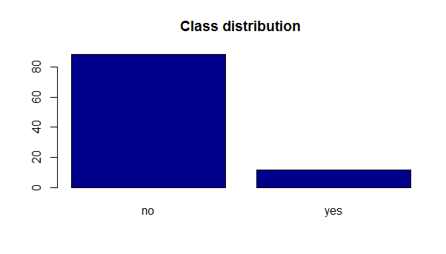
The frequency distribution according to the number of customers who subscribe/not a term deposit showed that the number of customers who subscribe a term is 88.3% and 11.69% of customers subscribe a term deposit.

Figure 3 Figure 4

Figure 5
These charts in Figure 3, Figure 4, and Figure 5 show the distribution of customers who bought term deposits in the divorced, married, and single marital statuses. They show that for a successful telemarketing campaign, the managers should compile their telemarketing calling list by first targeting the single customers, then the married customers, and the divorced customers last.

Figure 6

Figure 6 shows that customers with tertiary education are more likely to subscribe to long-term deposits.

Figure 7

Figure 7 show that bank customers without a a previous loan default is more likely to subscribe to long-term deposits.

Figure 8.
Figure 9 shows that customers without a housing loan are more likely to subscribe to long-term deposits.
Figure 9 shows that customers who do not have a personal loan are more likely to subscribe to long-term deposits.

Figure 10 shows that customers when contacted in March, September, October or December are more likely to subscribe to long-term deposits.
Figure 11 shows that customers in management type of jobs who have subscribed before are more likely to subscribe to long-term deposits.
Figure 12 shows that customers with no loan are more likely to subscribe to long-term deposits.
Figure 13 shows when customers are contacted during the middle of the month, they are more likely to subscribe to long-term deposits.
Figure 14 shows that customers who are 60 years old and above are more likely not to subscribe to long-term deposits. (see right plot).
Figure 16 shows customers who accepted a previous offer are more likely to subscribe to long-term deposits and customers who rejected an offer in the past, are more likely to decline long term deposits offers.

Figure 17 shows customers who been contacted three times or less are more likely to subscribe to long-term deposits.
Figure 18 shows that customers with a bank balance between 0 and 2,500 Euros in the bank are more likely to subscribe to long-term deposits.

Data Preparation

Data cleaning
The bank’s marketing dataset csv file “bank-full.csv” was fairly clean. The csv file had 16 columns and 45, 211 rows. There were no missing values.

We removed the variable “duration”, which referred to the last contact duration in seconds. This attribute highly affected the output target (e.g., if duration=0 then y='no'). Yet, the duration was not known before a call was performed. However, after the end of the call, “y” was known. Thus, this column was not relevant. The number of features was reduced to simplify the development of the predictive model.

Feature selection

Rank features by importance
Ranking the features by importance gives insights in what columns are more discriminative in segmenting the customers into subscribed/not.
The graph presents the mean decrease in Gini index for each feature where features are presented from most important to least important. The graph demonstrates the need for removing the duration column.
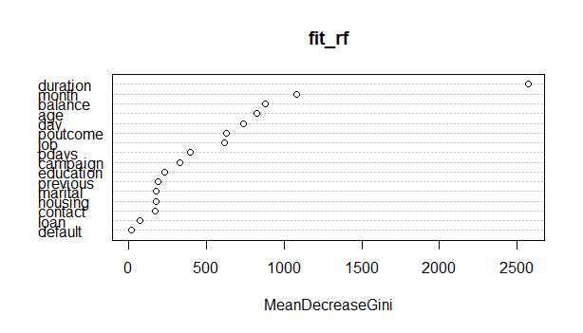
Figure 19: mean decrease in Gini index for each feature
Based on this graph, the most important attributes are month, balance, age, day, poutcome, job. According to Figure 10 presented in the exploratory data analysis section, we have shown that there are months where customers are more likely to subscribe compared to other months.
For the balance feature, Figure 18 has shown a peak in the number of subscribed customers given a range of values for the balance. This demonstrates the discriminant power of this feature in the classification task.
Also in Figure 14, it has been shown that when age is larger than 60, we could separate subscribers and non-subscribers in two different groups. This also justifies the important of age in classification.
For the day of the month the customers are last contacts, we have shown in Figure 13 that when customers are contacted in the middle of the month, they are more likely to subscribe to long-term deposits.
For “poutcome” and “job” features where “poutcome” refers to outcome of previous campaign, we have shown how the proportion of subscribers vary with respect to those two variables. This also demonstrates their important in predicting subscribed customers.

Tuning the number of columns
In this section, our goal is to select the most important columns for classification. Based on the previsous graph, we vary the number of columns to be considered and report the accuracy of the classification using decision trees, thus using only the training data (67% of the whole dataset). The results are shown in the following graph.

Figure 20: accuracy of decision tree classification model
Based on this graph, we can see that the most important 6 columns give a high accuracy. While adding more columns, the increase in accuracy was not high. Hence, we will only consider the top 6 columns in our next experiments, namely month + balance + age + day + poutcome + job.

Model Development
Our main task here is to predict if the client will subscribe a term deposit (variable y). This is referred to a classification problem. Building a classifier is based on two stages:
- Training the classifier, and
- Testing the classifier.

In our experiments, we split the dataset into 67% for training and 33% for testing.

There is a wide range of existing classification techniques, below is the list of classification methods that we used and compared to build a classifier.
- Decision trees
- Random Forest
- Naïve Bayes

Classification using Decision Tree

Training
One of the main criteria for building a decision tree model is the “stopping” criteria. In this experiment we tune the depth of the decision tree, with respect to the accuracy of classification, by using decision tree on the training set only. The results are presented in the figure below. We can see that the increase in accuracy for depth greater than eight (8) is not considerable when compared to the accuracy obtained for depth = 8.

Figure 21: accuracy of classification using decision tree on the training set only
The overall accuracy does not tell whether the classifier is able to predict more customers who are willing to subscribe when compared to customers who are not willing to subscribe. One of the challenges in banking marketing is to increase the classifier accuracy towards customers who are willing to subscribe. For this reason, we would like to shift the focus towards predicting subscribed customers and select classifier parameter values that can achieve this goal.
Below, we report the per-class classification accuracy on the training data while varying the depth of the tree. We can clearly see that as the depth grows, the classifier can detect more subscribed customers.
Depth | Per class accuracy (yes) | Per class accuracy (no) | overall
3 | 16.17% | 99.12% | 89.42%
5 | 18.18% | 99.05% | 89.59%
8 | 26.36% | 98.52% | 90.08%
10 | 31.78% | 98.33% | 90.55%
15 | 38.84% | 98.16% | 91.23%
20 | 40.59% | 98.01% | 91.30%
max | 40.71% | 98.00% | 91.30%
Figure 22: per-class classification accuracy on the training data while varying the depth of the tree
Based on this table, the increase in tree depth results in slight increase of overall accuracy, slight decrease in detecting non subscribed customers. However, the increase in the accuracy of predicting subscribed customers is cumulative. As per the goal of the system, the need for predicting subscribed customers is privileged, it is more beneficial to select a depth that is not too small in order to detect more subscribers on one hand, and not too big on the other hand as this may build a tree that overfits the training data and consequently may have low performance on the test data.
Hence, a depth that is between 15 and 20 would be reasonable for decision tree classifier.

Tree visualization
The following figure shows the plot of the decision tree model given a depth=3. For higher depth, the tree is not readable.
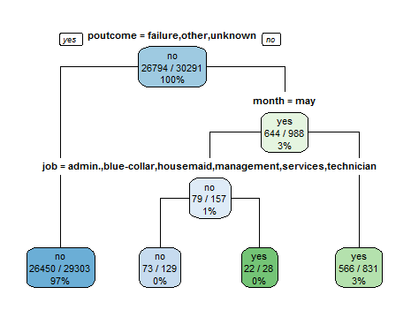
Figure 23: plot of the decision tree model given a depth = 3

Testing
In this experiment, we tested the classification accuracy by using a decision tree classifier on the testing data, and by comparing the impact of the depth on the classification accuracy. This is shown in Figure 8 below. Based on the result, as the depth of the tree grows, the accuracy decreases. This is mainly related with the fact that a high depth would result in overfitting the model with the training data. Hence a depth of 5 gives the best performance.

Figure 24: classification accuracy by using a decision tree classifier on the testing data, and by comparing the impact of the depth on the classification accuracy
In Table 3, we present the overall classification accuracy, the per-class classification accuracy on the testing data by considering different decision tree models with different depth.
Table 3: overall classification accuracy
Depth | Per-class accuracy (yes) | Per-class accuracy (no)
5 | 15.74% | 98.72%
10 | 24.84% | 97.10%
15 | 26.73% | 96.35%
20 | 27.24% | 96.05%
Max | 27.30% | 96.01%

The same observation on the training dataset is seen on the testing data. As the depth of the decision tree model increases the accuracy of predicting customers who subscribed increases. However, the increase is small when the depth is between 15 and 20.

Classification using Random Forest
In this experiment, we run the random forest classification on the training data. Figure 10, presents the impact of the number of trees used in the random forest classification on the error rates. Based on the results, as the number of trees grows, the error remains constant. Hence, the optimal number of trees that we considered in the random forest classification was 20.
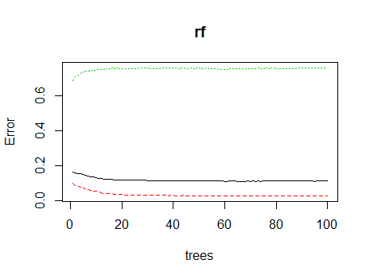
Figure 25: impact of the number of trees used in the random forest classification on the error rates
The overall classification accuracy and per class accuracy on training and testing are presented below.
Table 4: overall classification accuracy and per class accuracy on training and testing
 | Per class accuracy (yes) | Per class accuracy (No) | Overall
Training | 73.43% | 99.99% | 96.89%
Testing | 22.43% | 97.59% | 88.79%

Classification using Naive Bayes
In this experiment, we use Naive Bayes for classification along with using the six most important columns. The classification accuracy is as follows:
Table 5: classification accuracy when using Naïve Bayes
 | Per class accuracy (yes) |  | Per class accuracy (No) | Overall
Training (top 6 attr) | 24.78% |  | 96.27% | 87.91%
Testing (top 6 attr) | 23.92% |  | 96% | 87.56%
Training (all attr) | 40.00% | 90.78% |  | 84.85%
Testing (all attr) | 38.46% | 90.67% |  | 84.55%

The results show that using all attributes gives better performance in predicting subscribed customers although the overall accuracy and also the accuracy of predicting the non-subscribed customers have decreased. The selection of the most important features gives the highest overall accuracy, however, the results show that all the attributes are important in predicting the subscribed customers.

Comparison of the different classifiers
In this experiment, we compared the different classifiers using 67% of the dataset for training and 33% of the dataset for testing. In the testing dataset, there were 14,920 rows. The total number of subscribed or unsubscribed customers was as follows:
Table 6: total number of subscribed or unsubscribed customers
No | Yes
13173 | 1747

We compared the performance of the different classifiers on the testing data. The results are presented below.
Table 7: performance of the different classifiers on the testing data
Method | Accuracy
Decision tree | 89.01%
Random Forest | 88.85%
Naïve Bayes | 87.56%
In order to better compare the different classifiers, we present below the confusion matrix for each of the classifier.

Table 8: the confusion matrix for each of the classifier
Decision tree  no yes  no 13005 168  yes 1472 275 | Random Forest  no yes  no 12866 307  yes 1356 391 | Naïve Bayes  no yes  no 12647 526  yes 1329 418

Based on the confusion matrix, we calculated the per-class classification accuracy for each of the classifier.
Table 9: per-class classification accuracy for each of the classifier
 | Per class accuracy (yes) | Per class accuracy (No) | Overall accuracy
Decision tree | 15.74% | 98.72% | 89.01%
Random Forest | 22.38% | 97.66% | 88.85%
Naïve Bayes (top 6 attributes) | 23.92% | 96% | 87.56%
Naïve Bayes (all attributes) | 38.46% | 90.67% | 84.55%

Although decision trees and random forest classifiers have close overall accuracy, Random Forest outperforms the decision tree classifier in predicting subscribed customers (22.38% versus 15.74%).
Naïve Bayes classifier has lower performance in terms of overall accuracy, however, it gives the highest accuracy in predicting subscribed customers by considering all the attributes 38.46% while maintaining the accuracy of predicting non subscribed customers considerably high as the other classifiers (90.67%).

Five-fold cross validation
In this experiment, we compare the different classifiers using 5-fold cross validation and calculate the overall accuracy and the per-class classification accuracy for each of the class labels on the testing data.
Table 10:
Method | Per class (yes) | Per class (no) | Accuracy (mean 5-fold)
Decision trees | 25.33% | 96.72% | 88.25%
Random Forest | 20.31% | 98.54% | 89.25%
Naïve Bayes (top 6 col) | 38.65% | 92.98% | 86.53%
Naïve Bayes (all col) | 43.22% | 90.81% | 85.16%

Based on the results, as opposed to the previous experiment, by applying 5-fold cross validation on the training data, the decision tree model performs better in predicting the prescribed customers (25.33%) compared to random forest (20.31%). This is mainly due to the fact that random forest classification aims at separating related attributes into small decision tree models that may overlap in features and then combined the classification output from each of the tree models into a majority voting. In 5-fold cross validation the quality of the decision tree model is better than random forest as all attributes are present in a single tree that is used for classification. We believe that when the number of attributes is high (we expect >50 col), then random forest would better classify instances than the single decision tree model.
By looking at the Naive Bayes classification results, although the overall accuracy has dropped compared to DT and RF, however it has shown a higher accuracy in predicting subscribed customers, and is the highest when considering all attributes in the classification. Naïve Bayes works on Bayes theorem of probability to predict the class of unknown data set with an assumption of independence among predictors. It is considered fast relative to other classification algorithms. Also, Naive Bayes is known to outperform highly sophisticated classification methods.
In exploratory data analysis, we observed the importance of each feature on the outcome variable (customer subscription prediction). However, there are few pairs of features that we would think they could be correlated, namely previous and “poutcome” which refer to the number of contacts performed before this campaign and outcome of the previous marketing campaign respectively. Another pair that we would think of is, campaign and “pdays” which refer to the number of contacts performed during this campaign and the number of days that passed by after the client was last contacted from a previous campaign respectively. This would explain the high accuracy obtained using Naïve Bayes as it is based on the independence assumption between predictors.
Another reason of having higher accuracy using Naïve Bayes, is that the decision tree model or Random forest model may overfit the training data, and are more sensitive to the training sample used for building the models. The variability between training data and testing data has a high impact on the quality of the classification. However, Naïve Bayes is based on probability distribution and is less sensitive to the training sample.

Model Deployment
Deployment and demonstration of the classification model to the bank stakeholders would clarify:
- purpose and goals,
- limitations of the selected dataset, understanding, analysis, preparation and cleansing,
- challenges in model selection, preparation, execution,
- Interpretations, communication of results, learnings, and insights.

Monitoring
Monitoring the performance of the classifier means communicating regularly with the bank’s stakeholders and obtaining feedback. Then to use the feedback received to fine tune the model.

Review
Continuously review the outcome to the telemarketing campaign results. Feed more up-to-date data into the model to retrain its algorithm and improve its accuracy. Then, update the model in production to improve the bank’s telemarketing campaign success.

